

# **CS-2006**

**“OPERATING SYSTEM”**

**“PROJECT REPORT”**

**PROJECT TITLE:**

**UNIX SHELL (Combining Commands)**

**Group Members**

**Mohammad Usama 20K-0190**

**Fabiha Atique 20K-0369**

**Theory Instructor: Lab Instructor:**

**Ms. Tania Iram Ali Shah Fatimi**

**INTRODUCTION:**

The Project name is **“Unix Shell”.** It’s all about creating a new terminal in Linux, there are also other shells like zsh, bash etc. In this we add Different System Commands to perform Different Tasks like in Linux terminals. combined with the power and flexibility the command line offers, means that using it may be essential when we are performing different tasks.

**FEATURES:**

* **Interactive user interface**
* **Animated view**
* **Save Your Time**
* **Perfect for Programmers**
* **Command History**
* **Fast & Efficient**

**WHAT IS DIFFERENT IN OUR PROJECT:**

Many shells include zsh, bash, Tcsh/Csh, and Fish. In our project, the shell starts with an interactive user interface with an animated Display also it is named by the Developers, and there are also links for the others to follow the instructions for absolute beginners on how to use the Linux shell effectively.

Additionally Unix shell doesn't have the ‘cd’ command by default, so we add ‘cd’ and a unique command as well.

1. **cd:** The cd (“change directory”) command is used to change the current working directory in Linux and other Unix-like operating systems. It is the most frequent command used in Linux shells.
2. **pichetodekho:** This command will be showing which last command is executed with its output.

**TOOLS & TECHNIQUE:**

* **LINUX/ UBUNTU**
* **C LANGUAGE**
* **MACROS**
* **LIBRARIES**
* **USER-DEFINED MODULES**

**OUTPUTS**

**Welcome Screen**

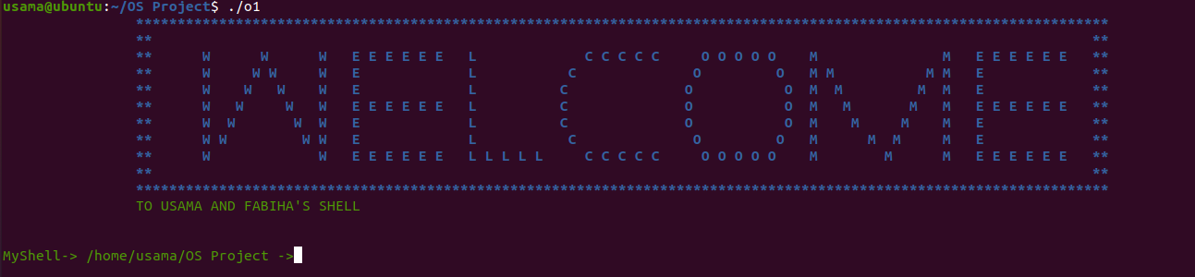

**ls & pwd**

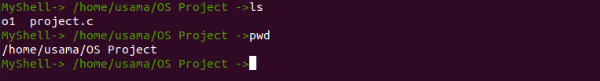

**cal & date**

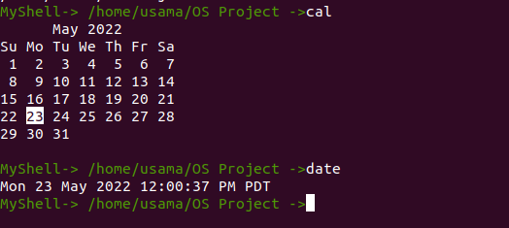

**cd & pichetodekho**

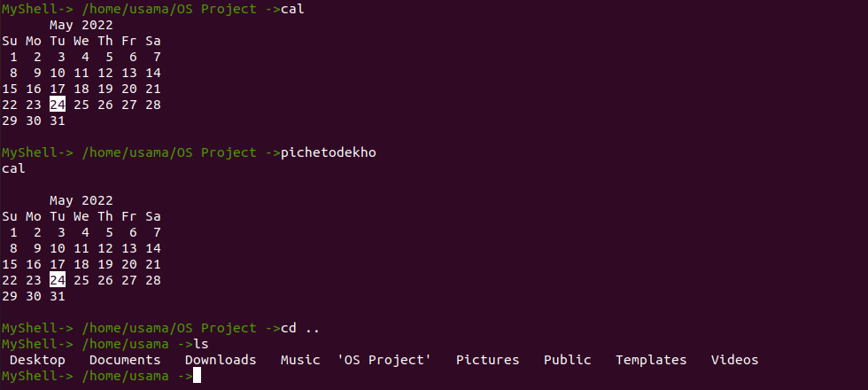

**CONCLUSION:**

You can see in above screenshots how the different linux commands are running and the coloring for coloring. We have used different macros in the code part, and It is very Fast, the user interface is too good, and the initial view of the Terminal is Animated. This is just like the zsh terminal. The idea of Animation comes in our mind from zsh’s oh-my-god terminal.